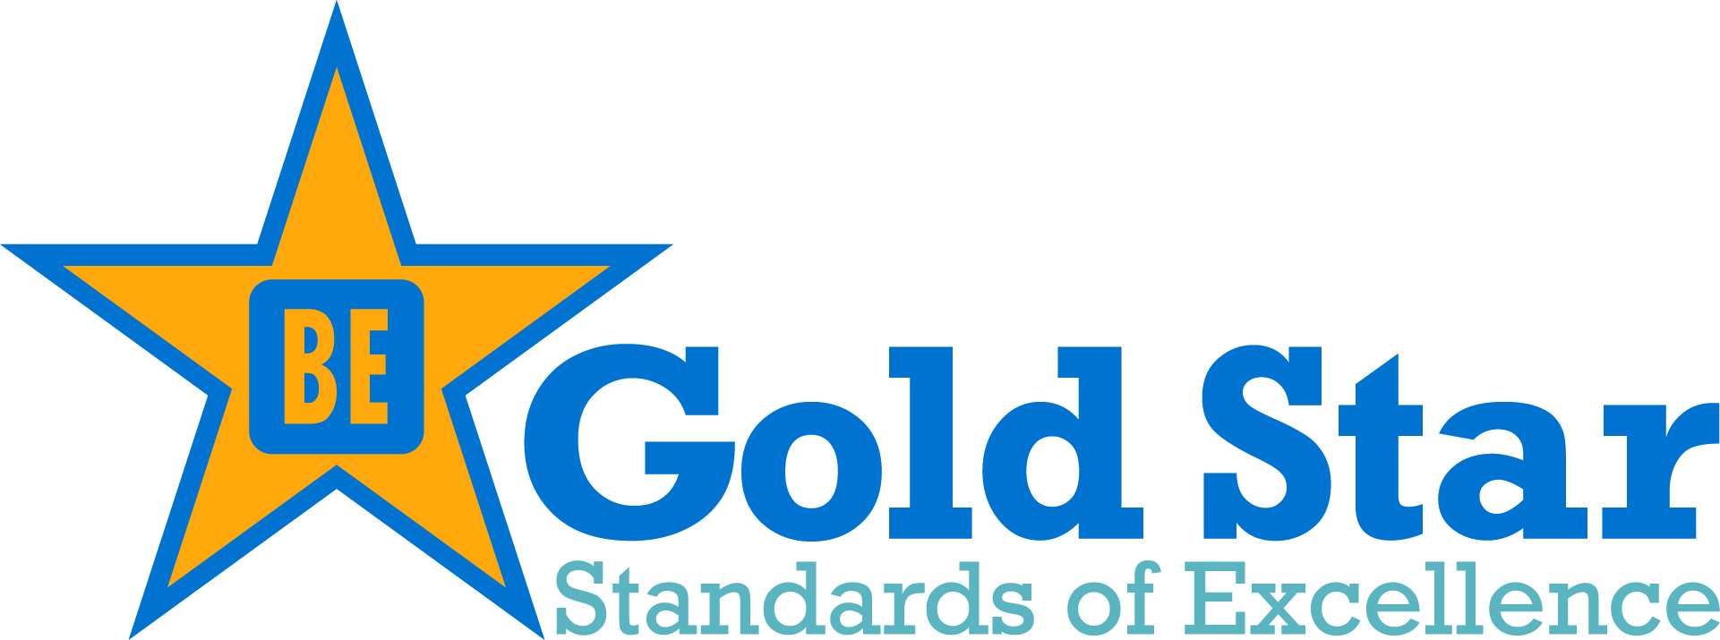

Nominate an Individual or Program as a Gold Star Champion

In addition to recognizing organizations and institutions for their progress in the tobacco-free movement, we also want to acknowledge the individual champions of smoke and tobacco-free policies and lifestyles. Please nominate any individual(s), program or unique approaches that should be publicly recognized during our Awards Celebration Event.

Name of Individual or Program:
_____________________________________________________________________________________
Title (Individual Only):
_____________________________________________________________________________________
Email address of person nominated or program contact:
_____________________________________________________________________________________
(Please note: Email address will only be used to invite the individual to the Awards Celebration event.)
What Makes this Individual or Program a Gold Star Champion? __________________________________________________________________________________________________________________________________________________________________________
_____________________________________________________________________________________
_____________________________________________________________________________________
__________________________________________________________________________________________________________________________________________________________________________
_____________________________________________________________________________________
_________________________________________________________________________________________________________________________________________________________________________________________________________________________________________________________________________________________________________________________________________________________________________________________________________________________________________

